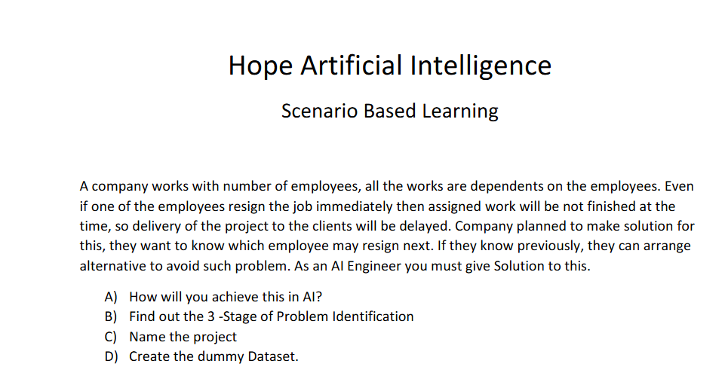

1. Based on employee performance rating and salary increment over the working period, we can analyze and find whether they will resign or not.
2. Since we are going to analyze the employee performance over working period, Step1 should be Time Series Analysis

Stage 2: Since we have clear requirement, we can go with Supervised

Stage 3: Classification as o/p will be employee may resign or not

C) Employee Resignation Prediction

D)

|  |  |  |  |  |  |
| --- | --- | --- | --- | --- | --- |
| Employee Id | Age | Salary | Performance rating | Year | Output |
| 101 | AAAA | 2000 | 5 | 2020 Sem1 | AAAA employee will **resign** based on performance over the period and salary increment |
| 101 | AAAA | 2000 | 5 | 2020 Sem2 |
| 101 | AAAA | 3000 | 5 | 2021 Sem1 |
| 101 | AAAA | 3000 | 5 | 2021 Sem2 |
| 101 | AAAA | 3000 | 4 | 2022 Sem1 |
| 101 | AAAA | 3500 | 5 | 2022 Sem2 |
| 101 | AAAA | 3500 | 4 | 2023 Sem1 |
| 101 | AAAA | 3500 | 3 | 2023 Sem2 |
| 101 | AAAA | 3500 | 2 | 2024 Sem1 |
| 101 | AAAA | 3500 | 2 | 2024 Sem2 |
| 101 | AAAA | 3500 | 1 | 2025 Sem1 |